Slides 6.11: Table Setting and Food Sharing Across Cultures, and the Methods Check
Slide outline for Lesson 6.11. Thirteen slides, one day. Slides 4 and 5 are the review deck for item 11 on the Cooking Methods Check. Cover the wall paths before slide 13.

Slide 1: The Table, Four Ways
- Unit 6, Lesson 6.11
- Topic 6.2 Food Preparation Methods and Science
- Today: a place setting, three other ways to serve, and the Methods Check Image: four small photos in a row: a set table, a shared platter, a bowl with chopsticks on a rest, a stacked tiffin carrier.

Slide 2: Do now
- Draw a place setting from memory
- Plate, fork, knife, spoon, cup, napkin
- Ninety seconds, no looking, no penalty for being wrong Notes: Hold up two drawings that disagree without saying which is right. Then uncover the three display stations.

Slide 3: Three ways to eat a meal, none with a fork on the left
- The place setting you just drew is one system out of many
- Every one of them was built to solve the same problem
- Your job today is to find the problem Image: the three display stations, photographed from above, no food in them. Notes: This is the hook.

Slide 4: The basic place setting
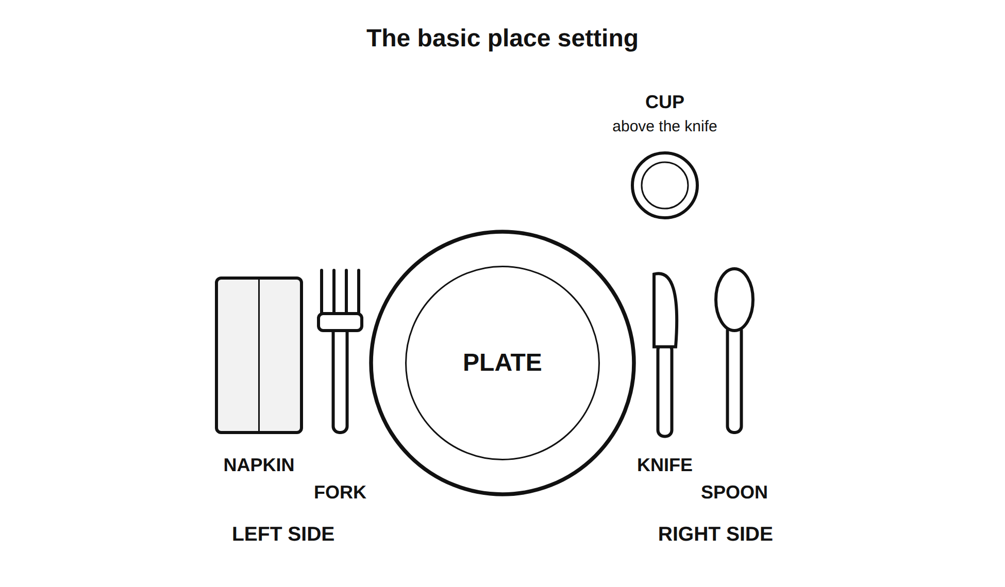
The basic place setting
- Plate center, about an inch from the edge
- Fork left. Napkin left of the fork
- Knife right, blade turned in toward the plate
- Spoon right of the knife. Cup above the knife Notes: Two reasons the blade faces in: it is safer, and it is the courtesy. Students set it and a partner checks and initials.

Slide 5: The formal setting and the outside-in rule
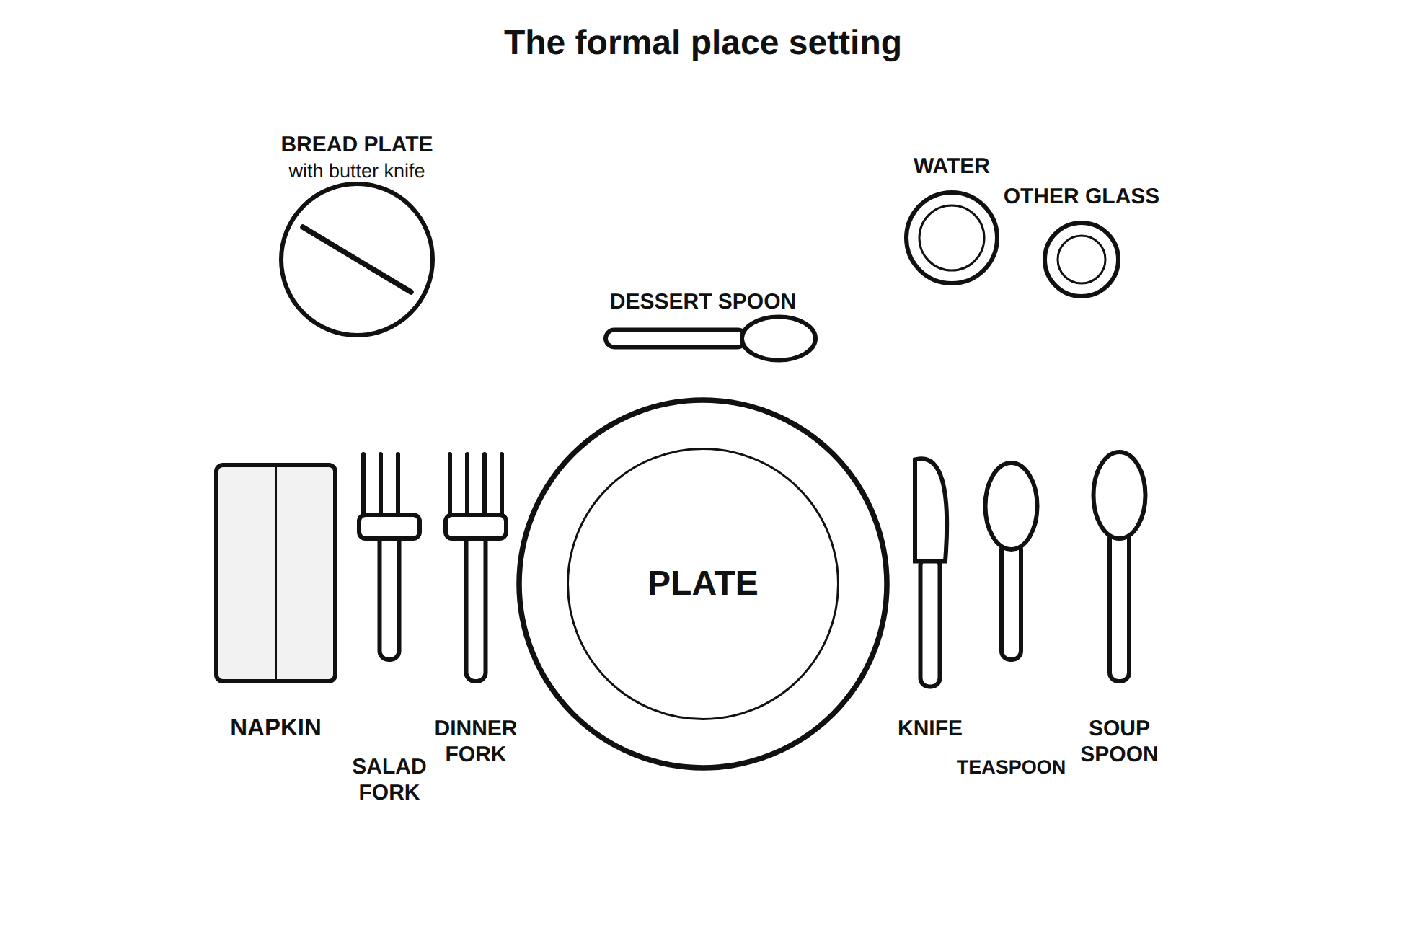
The formal place setting
- Use the utensils in the order the courses arrive
- Work from the outside toward the plate
- Soup first, so the soup spoon is farthest right
- Salad next, so the salad fork is farthest left Notes: Say the useful version out loud: if you do not know which fork, start at the outside and work in. That one sentence is what a formal setting is actually for.

Slide 6: Station 1, the shared platter
- One dish in the middle, small plates for each person
- The host serves, or everyone serves themselves with the serving spoon
- Guests and elders are served first
- Nobody takes the last piece without offering it Image: a large platter with a serving spoon and four small plates around it.

Slide 7: Station 2, chopsticks
- A pair used to lift food from a shared dish to your own bowl, then to your mouth
- They rest on a rest or across the bowl, never standing up in the food
- Do not spear food and do not point with them Image: a pair of chopsticks on a rest beside a rice bowl.

Slide 8: The right hand (the bowl beside Station 3)
- In many cultures food is eaten with the fingers of the right hand, often with bread as the scoop
- Hands are washed at the table, before and after
- The host offers first and waits until guests have started Image: a bowl of water and a folded towel beside a plate of flatbread.

Slide 9: Station 3, bento or tiffin
- Food in separate compartments, or stacked metal tins
- Carried from home or delivered
- Packed for balance and variety
- Returned clean Image: an open bento box with four compartments, and a three-tier stacked tiffin carrier beside it.

Slide 10: What all four have in common
- Every one of them has a rule about who gets served first
- And a rule about how much of the shared food is yours
- Every system exists so people get fed fairly and nobody has to guess Notes: Take the answer from the class before you put it on the screen. This is the “find the problem” payoff from slide 3.

Slide 11: Hosting basics, across all four
- Serve others before yourself
- Pass in one direction, and pass to the person who asked
- Wait until everyone has food before you start Notes: These three cross every system on the wall. They are also the three that get used on serving day in the Feed the Class project.

Slide 12: Write our agreement
- Three to five rules
- Each one is a thing a person does
- “Be respectful” is not a rule. “Serve the person next to you before you serve yourself” is a rule
- Then: one hard case. A situation where your rule would be difficult, and what you would do Notes: Groups of four draft, three groups read their strongest rule, class votes, final version goes on the wall. It governs serving day in Lesson 6.17.

Slide 13: Cooking Methods Check
- 12 items, 15 minutes
- Dry and moist heat, which method for which food, the leavening experiment, a lab scenario, a place setting item
- You may use your vocabulary card
- Desks clear, wall covered Notes: Sixty seconds of review before you hand it out: the two heat columns, the leavening rule, the four batch table, the place setting diagram. Read the directions aloud once. Collect at the bell. Retakes are allowed once after a review, per the Grading Plan, and the review fits in the first five minutes of the Feed the Class launch.

